`

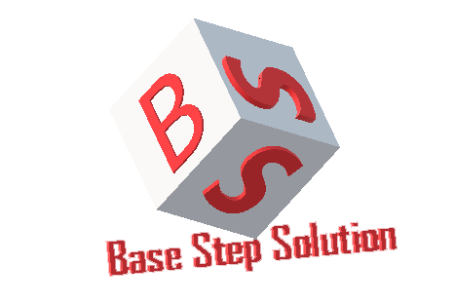

Meeting Minutes

Van Lang Admissions

# Revision Table

|  |  |  |  |
| --- | --- | --- | --- |
| Author | Date | Reason for changes | Version |
| Khoi Nguyen | 21/10/2016 | Initial Document | 1.0 |

Table of Contents

Revision Table 1

I. Purpose 3

II. Participant in meeting 3

III. Content of meeting 3

IV. To do task 4

|  |  |  |  |  |  |
| --- | --- | --- | --- | --- | --- |
| **Writer:** | Nguyễn Anh Khởi | **Location:** | CNF Coffee | | |
| **Date:** | 24/10/2016 | **Start:** | 13h | **Finish:** | 15h |

# Purpose

* Review Documents
* Discuss about solution for trainning
* Discuss about work environment

# participant in meeting

Mentor Lê Sĩ Phú

Team Capston:

* Nguyễn Thái Hiền
* Nguyễn Hoàng Anh Tài
* Đoàn Anh Minh
* Trần Xuân Hải
* Nguyễn Anh Khởi
* Nguyễn Xuân Thái Hiền

# Content of meeting

- Team development can work in Redsun company of Mr.Tien.

- Mentor suggest that All members go to work on time , try best for capstone

- Every working day at least 3 hours at Redsun

- Mentor advise to write plan and meeting with customer for next week

- Mentor advise to reseach and trainning after class , use Google calendar.

# To do task

* Learn software development ( NodeJS , MongoDB , AngularJS … )
* Write Project Plan
* Requirement Process , Incremental Process , Configuration Process , Communication Process …

---- *** ----